RAI Digital Twin
Summary: Before running or during the operation of an AI system in the real world, an RAI digital twin could be used to perform system-level simulation to understand the behaviors of AI systems and assess potential ethical risks in a cost-effective way.
Type of pattern: Product pattern
Type of objective: Trustworthiness
Target users: Architects, developers
Impacted stakeholders: Operators, data scientists
Relevant AI ethics principles: Human, societal and environmental wellbeing, human-centered values, fairness, privacy protection and security, reliability and safety, transparency and explainability, contestability, accountability
Mapping to AI regulations/standards: EU AI Act, ISO/IEC 42001:2023 Standard.
Context: The ecosystem of an AI system is complex, with multiple stakeholders and dynamic data sources. The data-dependent nature of AI systems implies a high degree of uncertainty in their behavior, which might cause harm to humans, society, and the environment.
Problem: What is a safe and cost-efficient way to understand the dynamic behavior of AI systems and investigate critical situations to assess the trustworthiness of AI components and AI system as a whole?
Solution: Simulation is designed to imitate a real-world situation. Before running AI systems in the real world, it is important to perform system-level simulation through an RAI digital twin running on a simulation environment to understand the behaviors of the AI system and assess RAI risks in a safe and cost-effective way, as illustrated in Figure 1. NASA introduced a digital twin as a digital representation of a real system used in lab-testing activities [1]. The digital twin of an AI system could be used to represent the behaviors of the AI system and forecast change impacts.
An RAI digital twin also can be used during operation of the AI system to assess the system’s runtime behaviors and decisions based on the simulation model using real-time data. The assessment results can be sent back to alert the system or user before the unethical behavior or decision takes effect [2].
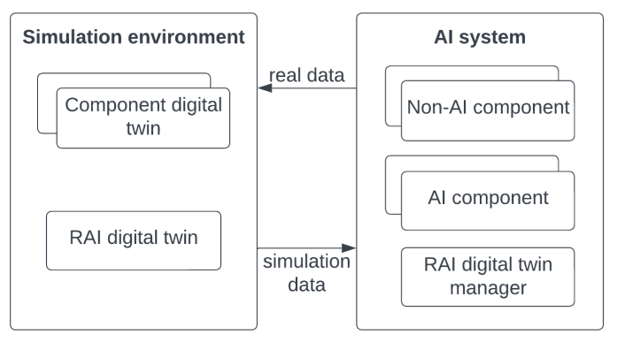
Fig.1 RAI digital twin
Benefits:
- Cost-efficiency: An RAI digital twin is a cost-effective way to assess the RAI risks of AI systems running in the real world.
- Increased RAI quality: Potential RAI risks can be detected in an RAI digital twin in a simulation environment. The assessment results are sent back to the AI system in the real world before the unethical behavior or decision takes effect.
Drawbacks:
- Limited by quality of the simulation model: The RAI digital twin is a simulation of the AI system. It could not fully represent what’s happening in the real world due to the dynamism of AI systems.
- Increased cost: Running and maintaining the RAI digital twin cause extra cost other than the operating cost of the AI system in the real world.
Related patterns:
- AI mode switcher: RAI digital twin could work with an AI model switcher to switch off the AI component in the real-world if a RAI risk is detected in the RAI digital twin.
- RAI sandbox: RAI digital twin is running in a simulation environment, while RAI sandbox is an emulation environment with both hardware and software.
- RAI knowledge base: RAI knowledge could provide a basis of RAI knowledge to the ethical RAI digital twin.
- System-level RAI simulation: A RAI digital twin performs system-level simulation at run-time using real-time data. The assessment results are sent back to alert the system or user before the unethical behavior or decision takes effect.
- XAI interface: A RAI digital twin performs system-level simulation at run-time using real-time data. The assessment results are sent back to alert the system or user before the unethical behavior or decision takes effect.
Known uses:
- NVIDIA DRIVE Sim is an end-to-end simulation platform for self-driving vehicles.
- rfPro is another software solution which provides driving simulation and digital twin for autonomous driving.
- AirSim is a project from Microsoft AI lab, which provides a 3D version of a real environment and a simulated drone.
References:
[1] Shafto, M., et al. Modeling, simulation, information technology & processing roadmap. National Aeronautics and Space Administration, 2012. 32(2012): p. 1-38.
[2] Dosovitskiy, A., et al. CARLA: An open urban driving simulator. in Conference on robot learning. 2017. PMLR.

